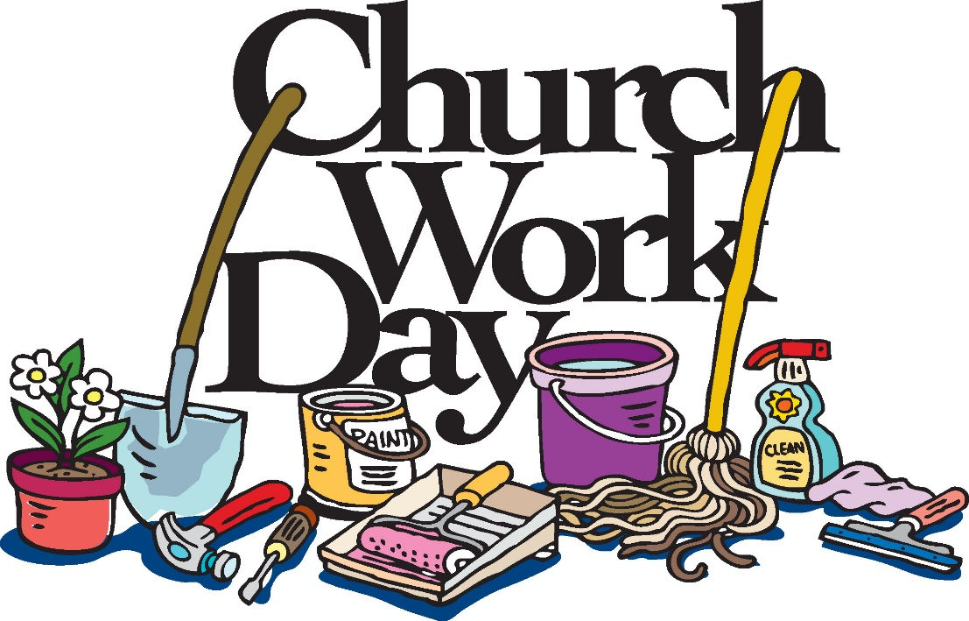

This Saturday

Oct. 17

9 am

AHBC