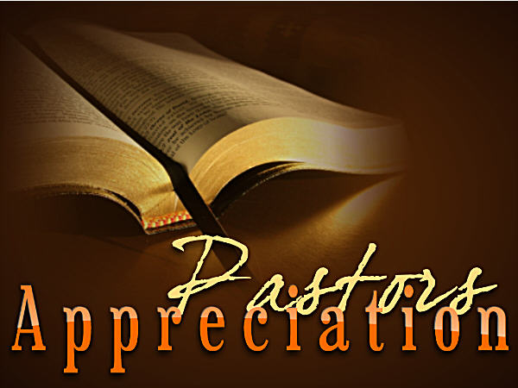

Come join us on Sunday, October 25
following the morning worship service for
the Family Fellowship Meal and
Pastor’s Appreciation Celebration
as we show our love & appreciation to

Pastor Ken Bolton & Pastor Haynes Searcy

There will be gift baskets for our pastors in the fellowship hall on Sunday 10/25.
This is your opportunity to let Pastor Ken and Pastor Haynes know that you appreciate the load they carry, the pressure of caring for the sheep, and the daily sacrifices they make for ministry.
In addition, don’t forget your pastor’s wife. She makes many sacrifices too in giving up her husband to ministry opportunities. Send these ladies (Galen and Kim) notes of appreciation also.
Let’s love on them and fill the baskets with cards, goodies, and gifts!

